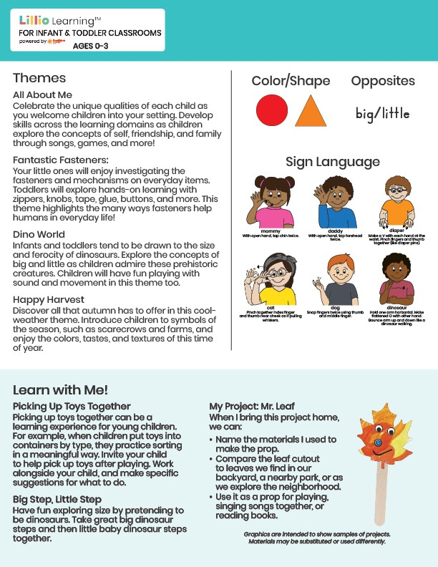

Sept/Oct 2024

NEWSLETTER

Add Name or Logo Here

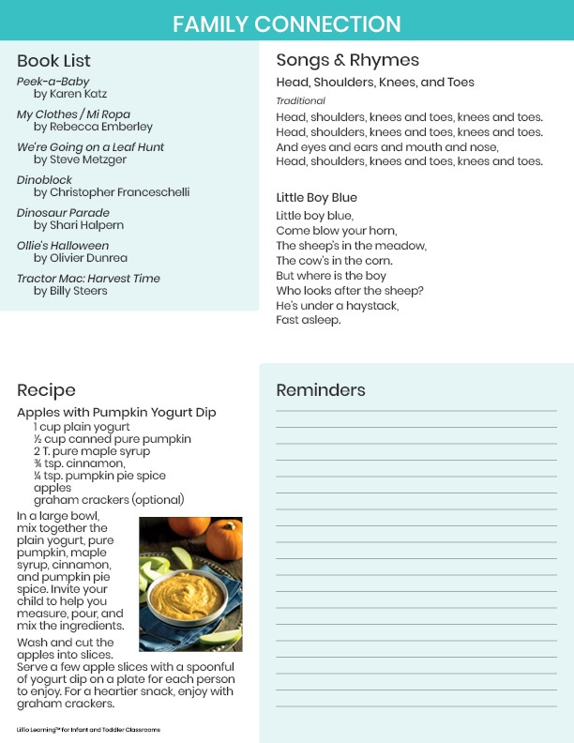

Add Notes Here